**Fiddler Classic**

**EXACT**

Rule

EXACT:https://static.zeuslearning.com/c/img/icons/qa-testing.svg

Find a file ->C:\Zeus Learning\Training\HTML-CSS\Assignment 4\Dashboard-Dynamic\images\imageMask.svg

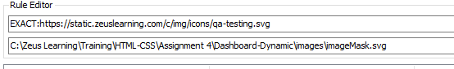

Before



After



**Regex**

Rule

regex:^https://static.zeuslearning.com/c/img/icons/.*

Find a file ->C:\Zeus Learning\Training\HTML-CSS\Assignment 4\Dashboard-Dynamic\images\imageMask-3.svg

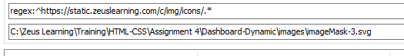

Before



After



**Fiddler Everywhere**

Using Exact

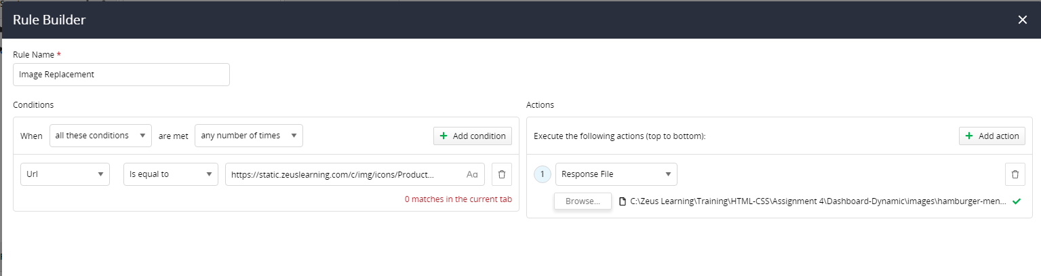

Before



After



Using Regex

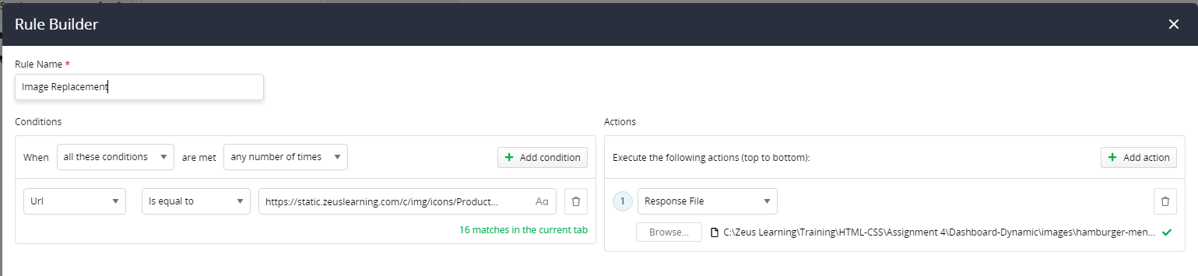

Before



After



Rules

